**Embed Canvas App in Dynamics 365 Model driven App**

1. Go to PowerApps and Sign in
2. Select Solution menu in the left-hand side
3. Select Default Solution and open it

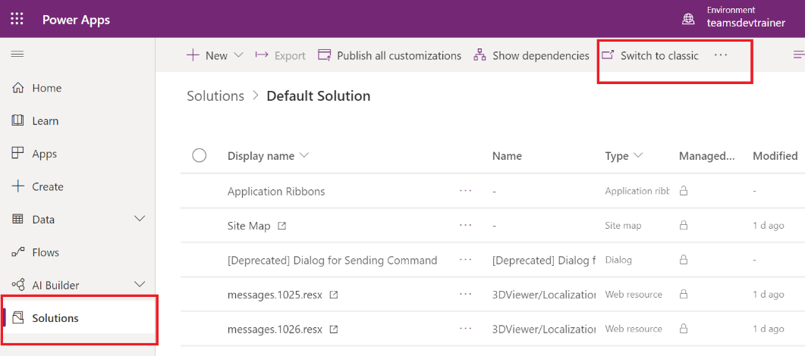

1. Click Switch to classic to edit the properties and layouts

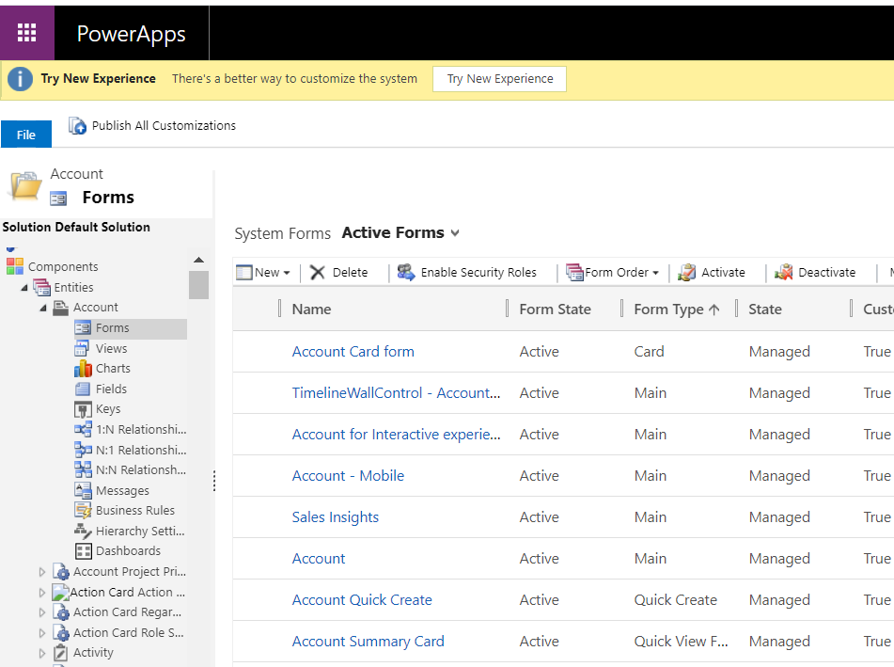

1. Select Entities 🡪 Account 🡪 Forms 🡪 Account (Main Form Type)
2. It will open the edit window

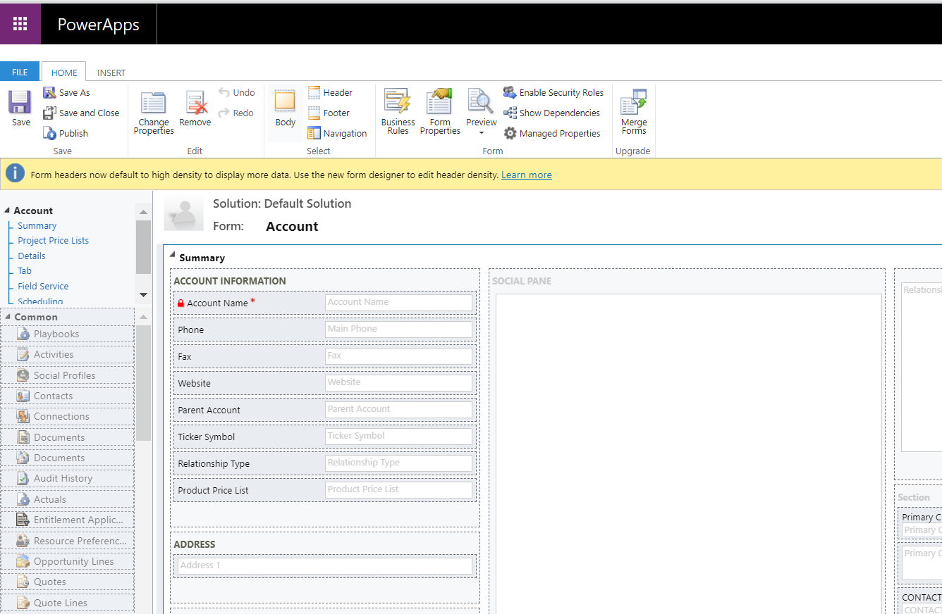

1. Go to Insert tab and Add new section for new tab to embed canvas app
2. Name the section as Custom Tab

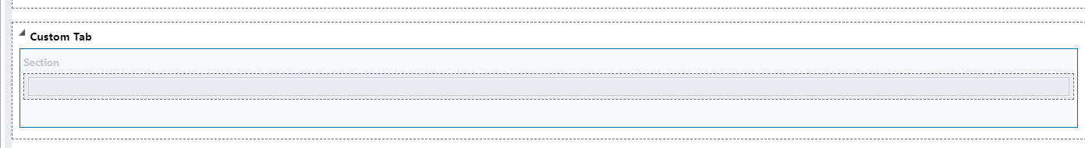

1. Add Account Name column
2. Double click and go to Field Properties
3. Go to Controls Tab

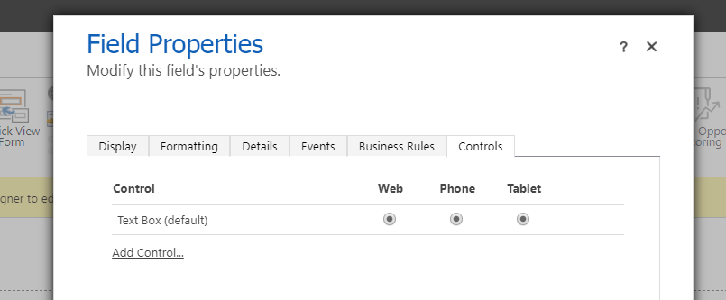

1. Click Add control and Select Canvas app

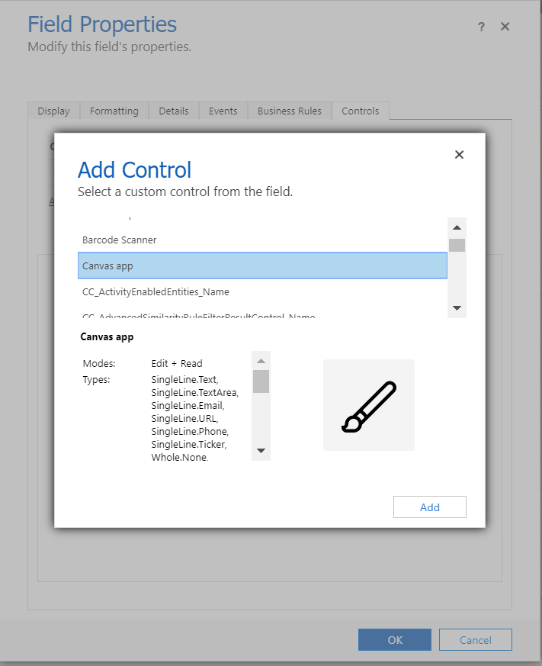

1. Click add to add canvas app to the control

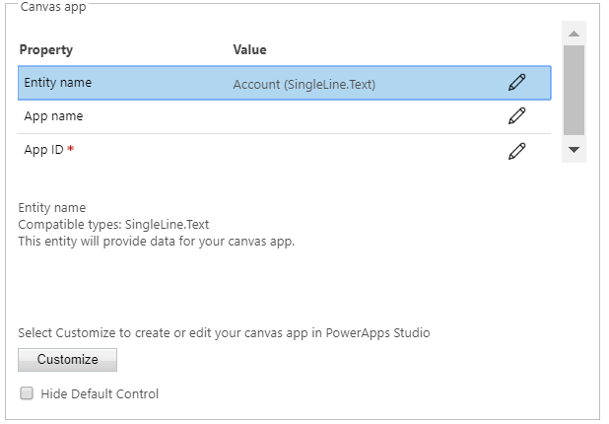

1. Click Customize button to add new canvas app
2. It will redirect and open power apps new window to create canvas app with account entity.

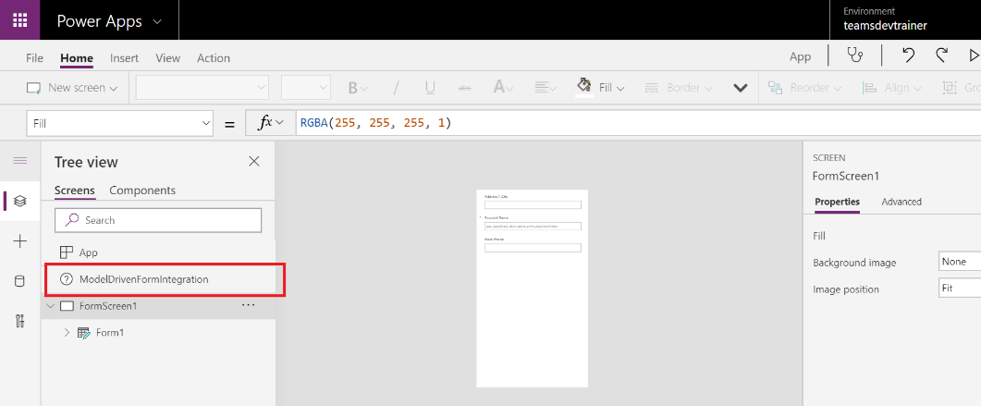

1. It will add ModelSDrivenFromIntegration link available in the screen section.
2. Save and Publish it

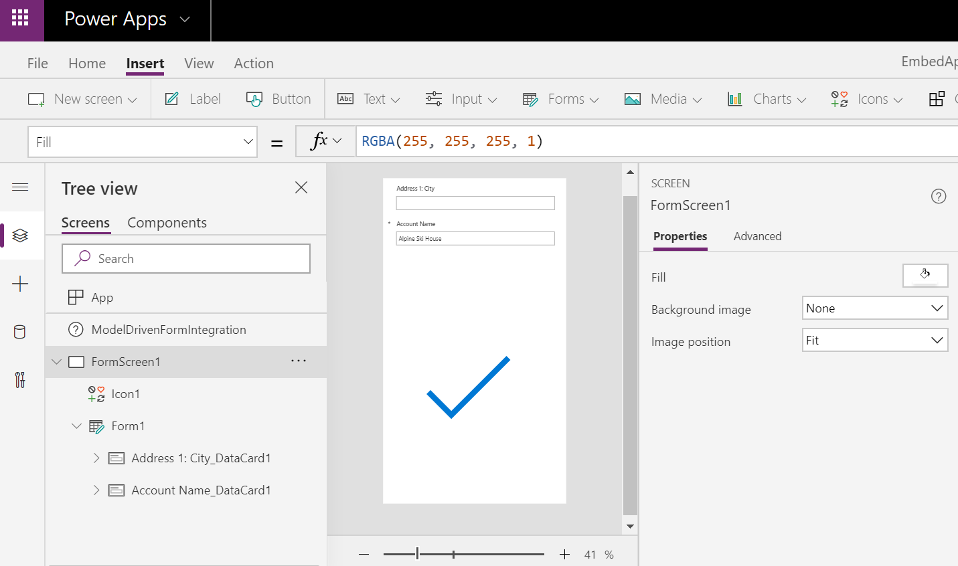

1. Now you can able to see the AppID and App Name in Field Properties window

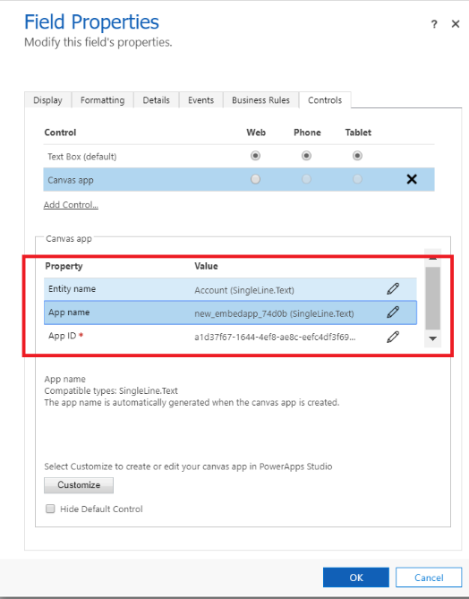

1. Save and Publish the account entity update.

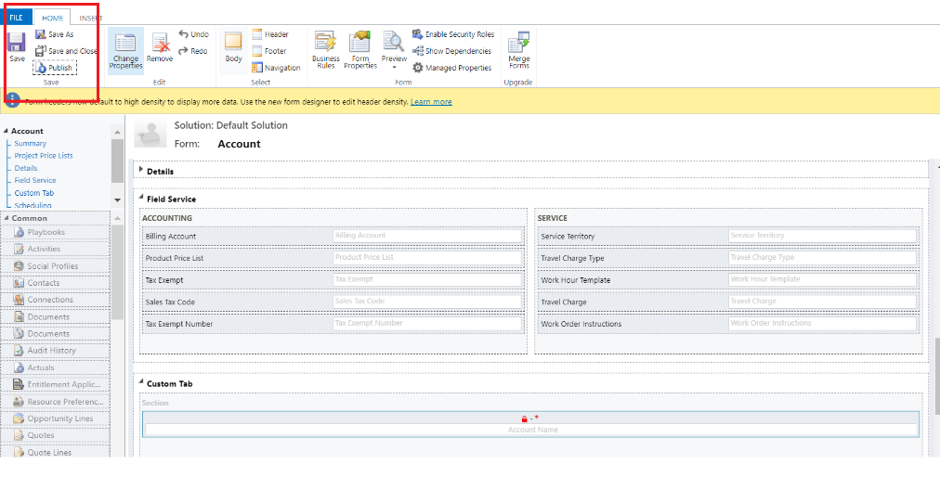

1. Test the canvas app
   1. Go to Dynamics 365 custom sales and marketing
   2. Open Account entity and click the account name to open the item
   3. Now you can able to see the new tab and inside the tab canvas app loaded.

